DEXTRANS WORLDWIDE GROUP
CargoWise One (CW1) — Process Guide

Capturing a Single Vendor Invoice Across Multiple Shipments
Using Consol-Level Cost Apportionment
Applies to: Singapore (DWSG) and China (SZX, TJN and other offices) operations teams
Reference process: Dextrans Malaysia (DWMY) current practice, confirmed with Razilah Zakaria, Operations Manager
Prepared by: Alwin Ng —Solutions Dept

1. Purpose
Vendors sometimes issue a single invoice (or Fapiao, in China) that covers charges across several shipments — for example, a monthly settlement invoice from a trucker, or a single Delivery Order / Destination Terminal Handling charge that applies to more than one house bill on the same consol.
Because CW1 does not allow the same vendor invoice number to be posted more than once against the same creditor, some offices have been working around this by appending "-1", "-2", "-3", etc. to the real invoice number so it can be posted separately against each shipment. This creates a mismatch between the invoice number in CW1 and the actual vendor invoice / Fapiao number, which affects reconciliation, audit trail, and — for China — tax documentation.
This guide sets out the correct process, based on how Dextrans Malaysia currently handles this scenario: post the vendor invoice once, at the consol level, using the true invoice number, and let CW1 apportion the cost automatically to each linked shipment.

2. When to Use This Process
This process applies when:
- A single vendor invoice / Fapiao covers costs for two or more shipments; and
- Those shipments can be grouped under one consol job (i.e. they share the same vendor movement — same carrier, voyage, and load/discharge ports).
If the shipments in question are not already linked to a common consol, the consol must be created first (or the shipments attached to an existing consol) before this method can be used. If shipments genuinely cannot share a consol, please flag this back to Alwin so an alternative solution can be reviewed — do not default to modifying the invoice number.

3. Overview of the Process
At a high level, the process has three parts:
- Create the individual shipments as normal, each with its own house bill.
- Create (or open) the consol job and link all relevant shipments to it.
- Post the vendor invoice once, under the consol's Accounting tab, and let CW1 apportion the cost across the linked shipments automatically.

4. Step-by-Step Walkthrough

Step 1 — Create the Shipments
Create each shipment in the usual way, under Basic Registration, with its own unique House Bill number, and the correct Origin, Destination, Weight, Volume and Chargeable details. Each shipment keeps its own house bill — nothing changes here.
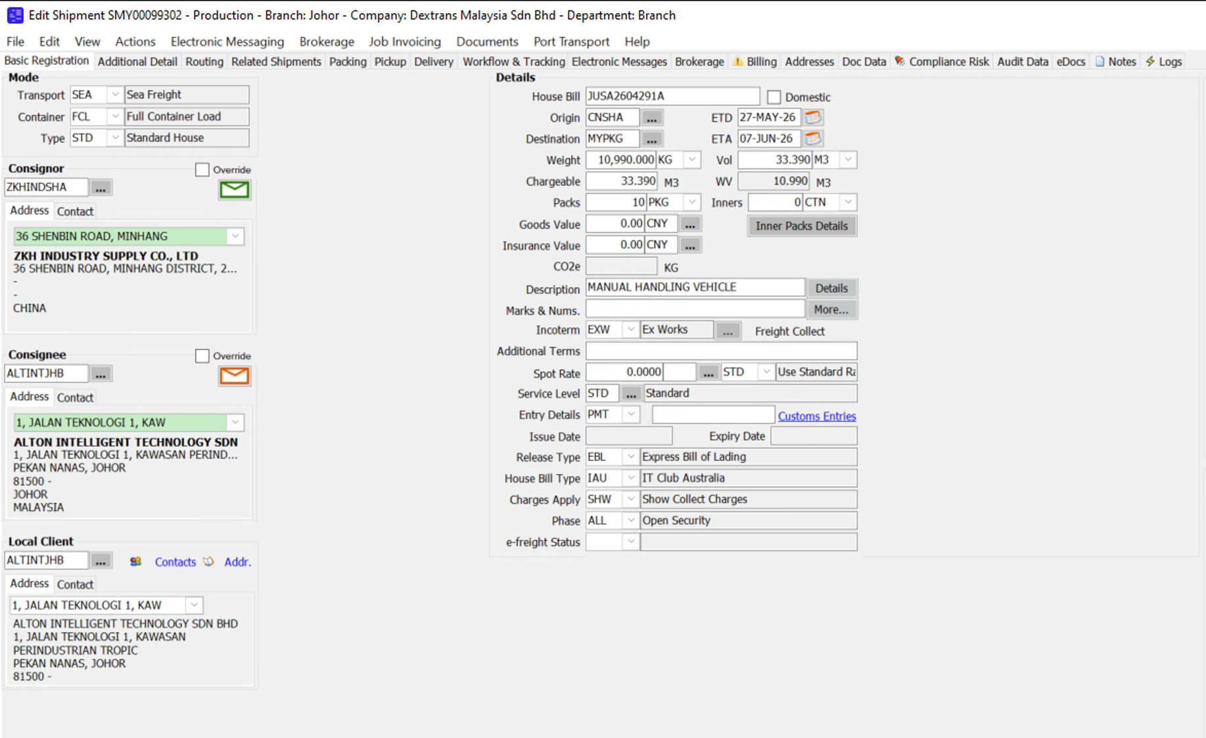
Example — Shipment SMY00099302, House Bill JUSA2604291A (Weight 10,990 KG / 33.390 M3)

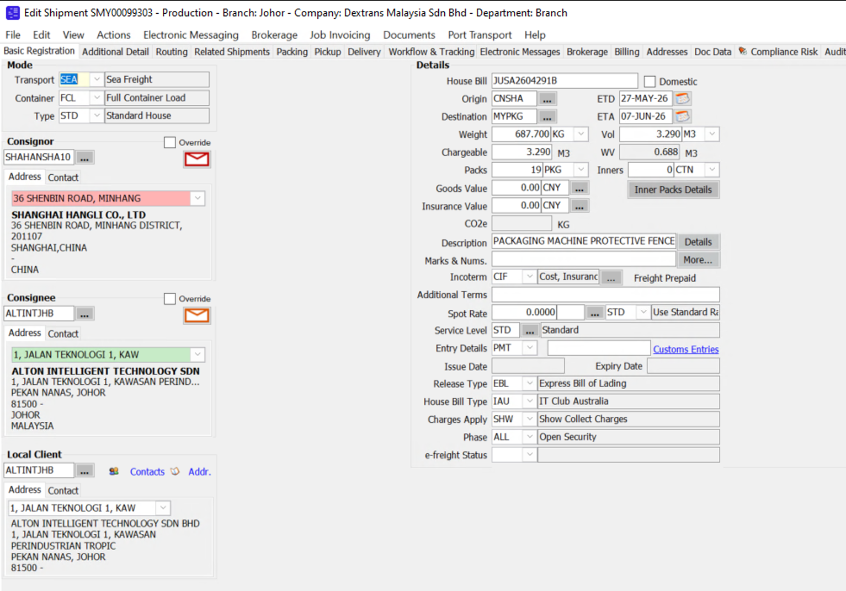
Example — Shipment SMY00099303, House Bill JUSA2604291B (Weight 687.700 KG / 3.290 M3), same Origin/Destination and consignee, forming part of the same consol movement

Step 2 — Create the Consol and Link the Shipments
Create the consol job for the vendor's movement (e.g. the carrier voyage) as normal. In the consol's Details tab, the shipments grid at the bottom of the screen lists every shipment attached to that consol. Attach all shipments that are covered by the single vendor invoice to this one consol.
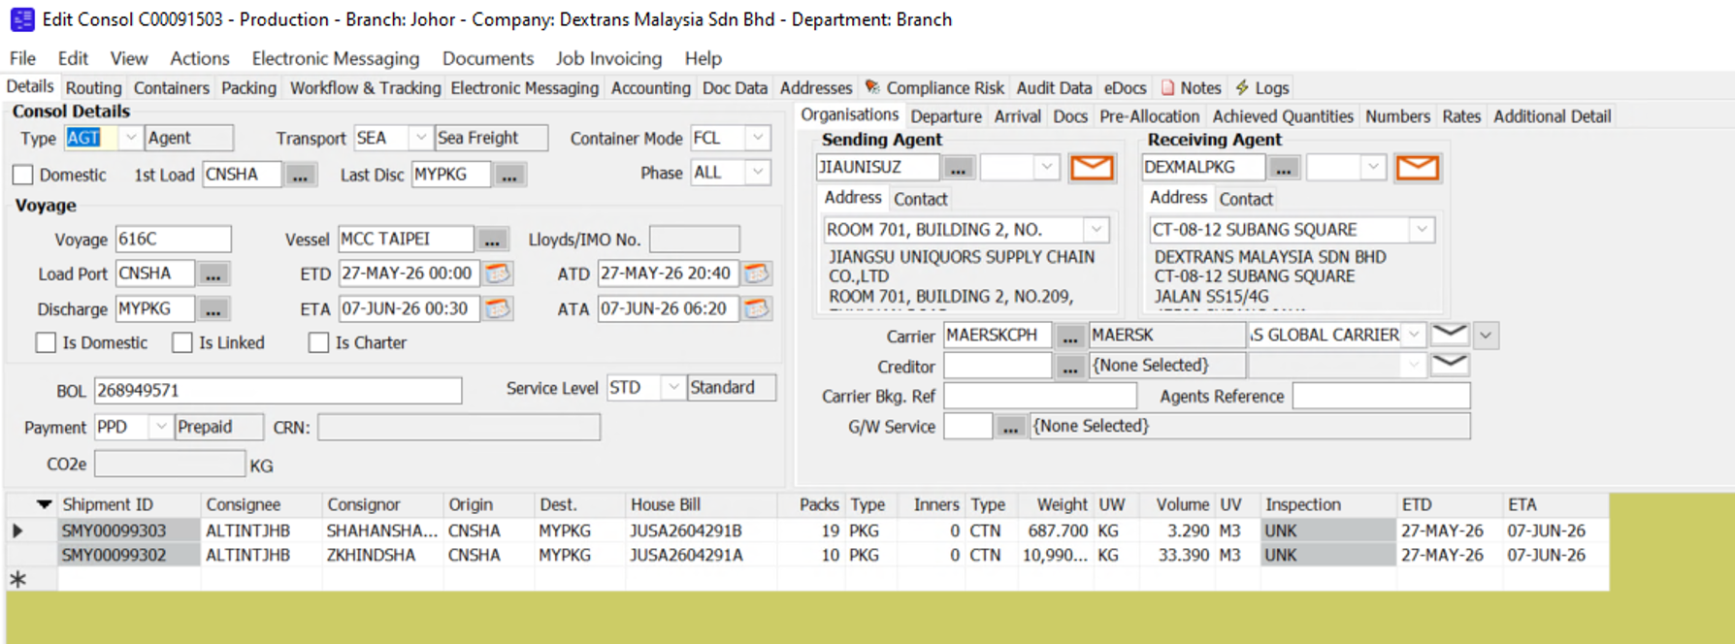
Example — Consol C00091503 with both SMY00099302 (House Bill JUSA2604291A) and SMY00099303 (House Bill JUSA2604291B) linked in the shipments grid
Confirm both shipments appear correctly in this grid before proceeding — this link is what allows CW1 to apportion costs to them later.

Step 3 — Post the Vendor Invoice Once, at Consol Level
Open the consol job and go to Accounting → Consol Costing. This is where the single vendor invoice is captured — only once, using the real invoice number and creditor.
- Add a cost line for each charge on the vendor invoice (e.g. DTHC, DOF), entering the true Invoice #, Creditor, Invoice Date and OS Cost Amt exactly as shown on the vendor's document. Do not add suffixes or alter the invoice number.
- Set the Apportionment field to ALL, so the charge is spread across every shipment linked to the consol.
- Set the App. Method to the appropriate basis — CHG (chargeable weight/volume) is used in the Malaysia example below, apportioning by each shipment's share of total chargeable quantity.
- Once saved, CW1 automatically calculates each shipment's share of the cost in the Apportioned Charges grid at the bottom of the screen. Verify the split adds back up to the invoice total before posting.
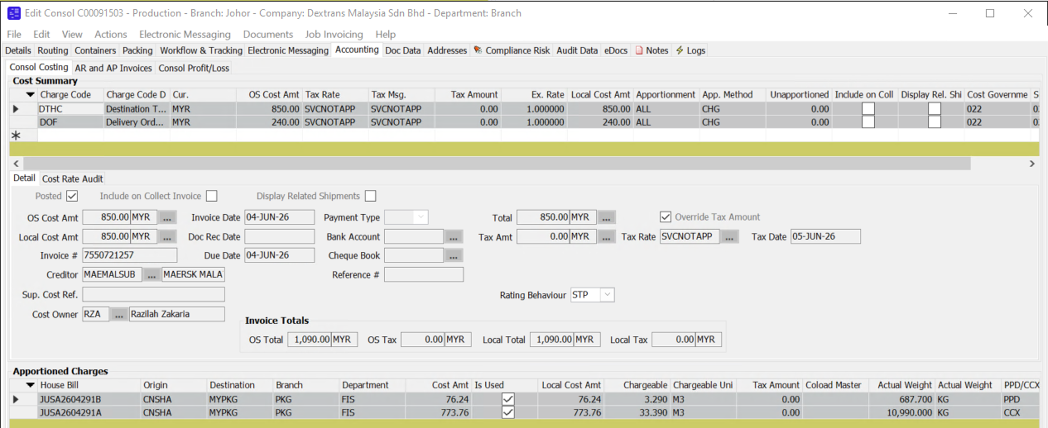
Example — Consol Costing: Invoice #7550721257 (Creditor: MAERSK MALA) posted once for DTHC (850.00 MYR) and DOF (240.00 MYR). CW1 apportions the DTHC charge by chargeable volume: JUSA2604291A (33.390 M3) receives 773.76 MYR and JUSA2604291B (3.290 M3) receives 76.24 MYR — the two amounts total the 850.00 MYR invoiced.

5. Result
- The vendor invoice number in CW1 matches the actual invoice / Fapiao exactly — no suffixes, no duplicated or invented numbers.
- Each shipment's job costing correctly reflects its share of the vendor's cost, calculated automatically by CW1 rather than manually.
- Reconciliation against the vendor's statement, and — for China offices — against Fapiao records for tax purposes, becomes straightforward, since one invoice number in CW1 always corresponds to one real invoice.

6. Important Notes
- Please stop using the practice of appending "-1", "-2", "-3" (or similar) to vendor invoice numbers going forward.
- If an invoice number appears to be a duplicate when posting, check first whether the shipments should be linked under one consol rather than modifying the number.
- For China offices: where the Fapiao has not yet been received from the vendor at the time of cost accrual, please key in the accruals and DO NOT post AP transactions until invoice is received from vendor.
- If your shipments span more than one consol, or the vendor invoice covers shipments that cannot be linked to a single consol, please escalate to Alwin before posting.

7. Questions
If anything in this walkthrough does not match what you see in your CW1 screen, or if you hit an issue applying it to a real invoice, please reach out before working around it — this ensures we keep the process consistent across all offices.
Alwin Ng
Solutions Dept, Dextrans Malaysia
alwin.ng@dextransgroup.com

